# Analyzing HAC Reduction Penalty Likelihood

*Brian Roberson, MPA*  *Emily Jones, MPH*

The third of the Affordable Care Act's quality incentive programs, the hospital acquired-condition (HAC) reduction program, is set to go into effect in FY 2015.

This program aims to incentivize the reduction of costly and often fatal harm events, estimated to cause 99,000 deaths and add as much as $33 billion to the nation's healthcare costs annually.[1] While all agree that this is a worthy goal, some have suggested that the program's penalties do not effectively measure differences in quality. Notably, the American Hospital Association (AHA) has raised concerns that teaching hospitals and hospitals of 400 beds or larger will be penalized disproportionately.[2] If this is the case, the program may have the unintentional consequence of systematically taking funds from hospitals that already face resource shortages, leading to poorer outcomes for vulnerable communities.

The Essential Hospitals Institute is interested in determining the effect of this program on the members of America's Essential Hospitals specifically and, more generally, those hospitals that have made it their mission to care for the nation’s vulnerable populations. We begin by investigating the concerns raised by the AHA using CMS' own predictions recently released in the FY2015 Inpatient Prospective Payment Proposed (IPPS) rule. We then analyze the effect of the program on members of America's Essential Hospitals. Finally we explore further relationships between patient acuity and HAC reduction program penalties.

## Methods

This study was conducted using preliminary data from CMS' FY2015 IPPS rule. Additionally, we utilized demographic data gathered as part of the AHA annual survey of members, to examine the expected penalties under the program by size, teaching status, membership in America's Essential Hospitals, and transfer adjusted case-mix index. *P* values for all statistical tests are 2-tailed and alpha is set at 0.001. Analyses were performed using R version 3.0.2 and R Studio version 0.98.501.

## Results

Recently released preliminary data from CMS' FY2015 Inpatient Prospective Payment Proposed rule estimates that 772 hospitals will be penalized under the program with a one percent reduction in hospital payments from the Centers for Medicare & Medicaid Services.

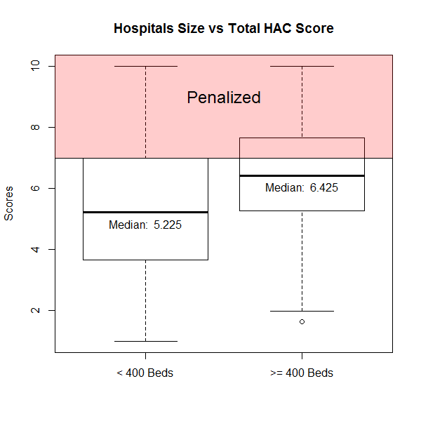

**Figure 1: Comparison of Penalties: Hospitals with**

**400 beds or more**

Data obtained for period from xxx, 20xx to xxx, 20xx

This estimation shows that 38.12 percent of hospitals with 400 beds or more will be penalized. Teaching status, defined in our analysis as being a member of the Council of Teaching Hospitals, faced penalties at a rate of 54.47 percent.

A chi-square test of independence was performed to examine the relation between a hospital size of 400 beds or greater and penalties under the HAC reduction program. The relationship between these variables was significant, X2(1, N = 3263) = 68.17, p <.001. Larger hospitals were more likely to be penalized under the program.

A similar chi-square test examining the relationship between teaching status and penalties also returned significant results, X2(1, N = 3263) = 150.10, p <.001, indicating that teaching hospitals were also more likely to be penalized under the program.

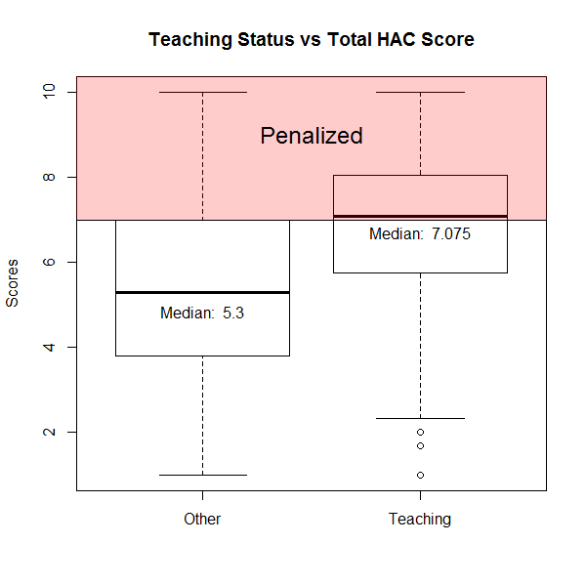

**Figure 2: Comparison of Penalties: Teaching Hospitals**

Data obtained for period from xxx, 20xx to xxx, 20xx

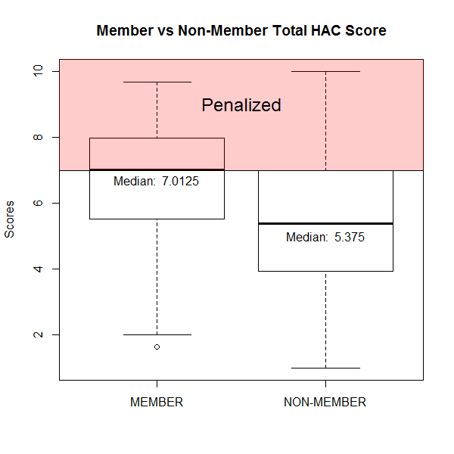

**Figure 3: Comparison of Penalties: America's Essential Hospital Membership**

Given these finding it is not surprising that Essential Hospitals, comprised of many large academic medical centers, also prove to be disproportionately affected by these penalties. Nearly 50 percent of Essential Hospitals are facing penalties under the program, leading to concern that its methodology is leading to a systematic punishment of those hospitals that treat the nation's sickest patients.

To investigate this concern, we examined estimated penalties under the program with respect to CMS' reported transfer adjusted case-mix index (CMI), a measure of patient acuity. After dividing hospitals into their respective CMI quartiles, a relationship between patient acuity and penalization can be seen. Furthermore, the odds of a hospital in the upper quartile of CMI being penalized were 1.81 times that of those falling below that threshold.

**Table 1: Comparison of Penalties: Teaching Hospitals**

|  |  |  |  |  |
| --- | --- | --- | --- | --- |
| Transfer Adjusted Case-Mix Index Grouper V31 | | | | |
|  | 1st Quartile | 2nd Quartile | 3rd Quartile | 4th Quartile |
| Not Penalized | 686 | 641 | 628 | 565 |
| Penalized | 134 | 166 | 188 | 255 |
| Percent Penalized | 16.34% | 20.57% | 23.04% | 31.10% |

Note: Data obtained for period from xxx, 20xx to xxx, 20xx

## Discussion

1. Centers for Disease Control, 2009
2. AHA comment letter: